Word Frequency Counter

**Environmental Setup:**

* Run “npm install” in root folder as well in /api folder
* Run “ng serve --proxy-config proxy.conf.json” in root folder to run angular app
* Open “\WordFreqCounter\api” path in cmd & Run “npm start” for api
* Open url “http:localhost:4200” in browser

**Demo:**

1. Type text & hit enter

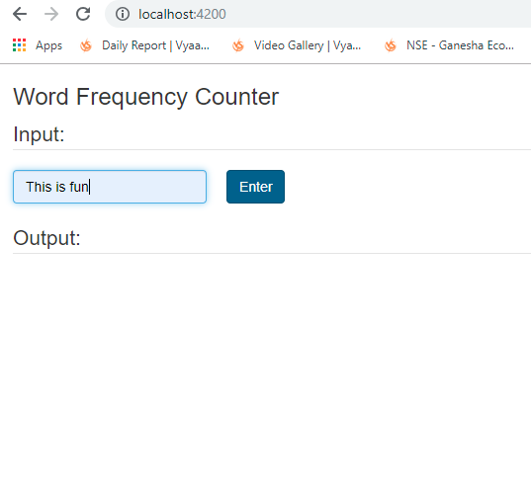  
  
2) save data & get back saved data  
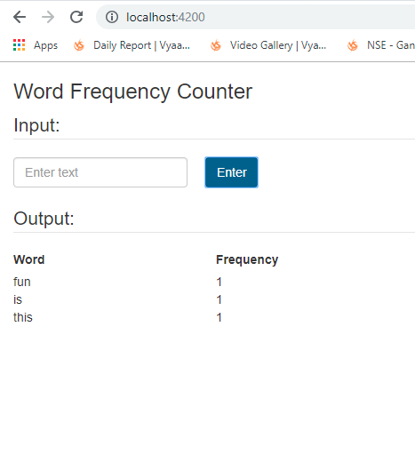  
  
3) Enter second text & save data  
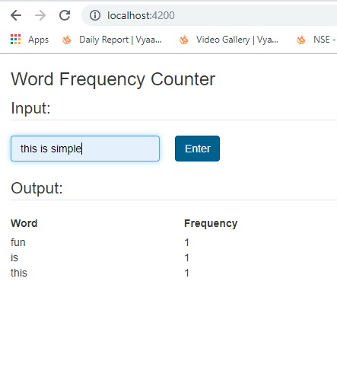  
  
4: get saved word  
